Kirin Harrington

Kirin@twosmallpeople.co.uk

LO3 Design document

Unit 2 LO3

Kelham Island Design Document

D Parr

Contents

Introduction 1

Schedule 1

Sitemap 2

House style 2

Colour scheme 2

Fonts 3

Mood board 4

Wireframe 5

Assets required 6

Conclusion 6

# Introduction

This is a document outlining the process of creating my virtual reality project, such as ideas about how the GUI would look, and potential assets I could need, it would also include information regarding keeping to a time scheme as I have a deadline for this project. This document will be very helpful as the detailed information will greatly speed up the creation of my project.

# Schedule

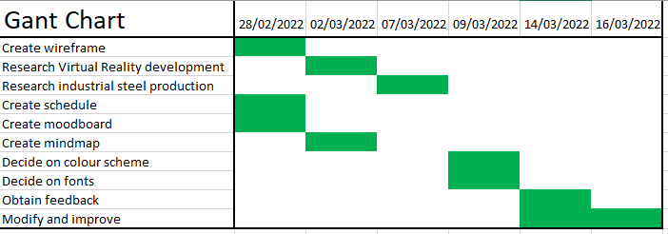

I created a plan to help me achieve specific smaller goals, this will help me to make sure I stick to the time frame, it will also make the project appear more achievable as it splits it down into small, manageable steps or pieces of work, I chose a Gant chart to represent this as it is a simple, very clear and easily understandable way to represent the goals in relation to the time I have. This means it will be very convenient to keep track of what I’ve already done and inform me of what I still have to complete and encourage me to complete it.

# Sitemap

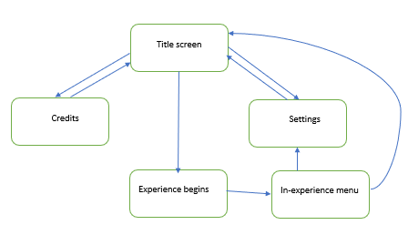

This is a simple and easy way to represent and visualise the way the pages in my document connect together, this will make it easier to create as it is a simple plan which illustrates how I need to code the movement between the different areas in my project.

# House style

### Colour scheme

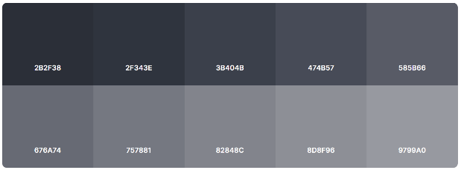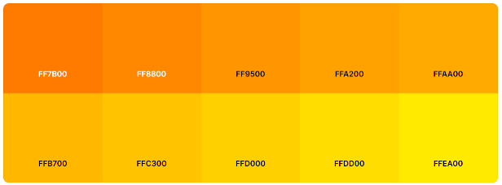

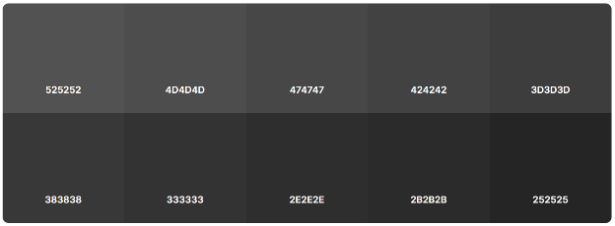

I chose these colours for my colour scheme because they fit the theme of the industrial metal colours and the colour of molten steel and fire.

I would use the darker oranges for the title, FF9500 and FF8800. For the background I would use a gradient between a lighter and darker grey, 3B404B and 676A74.

### Fonts

Main text

For example:

The Bessemer process was the first inexpensive industrial process for the mass production of steel from molten pig iron before the development of the open-hearth furnace.

Titles

For example:

Bessemer converter

I would use the first font “Agency FB” with a size of 14 for the majority of the text in the virtual reality experience, it would allow people with worse eyesight to understand and read it with less effort due to spaces between the letters, and the letters are reasonably big meaning that they are easier to see. I would use the second font “Bauhaus 93” with a size of 22 for titles, even though the font is harder to read, the size will mean that it will still be very easy to read by everyone, and it sets the mood as an industrial style project.

# Mood board

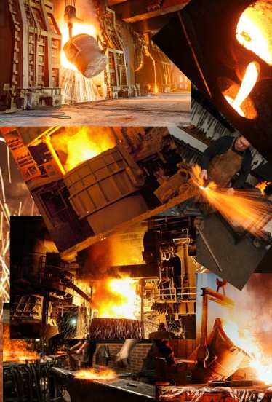I collated images relating to the theme of my project and of potential assets that will be in my project and arranged them in a mood board to give an idea of what my project will include and to provide inspiration while making my project. I will also have to create some of the images as 3d models to be featured in my VR project.

# Wireframe

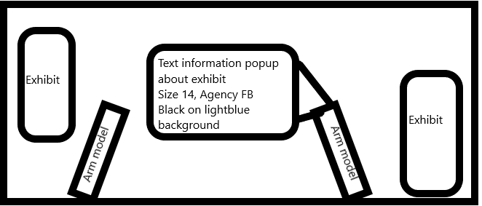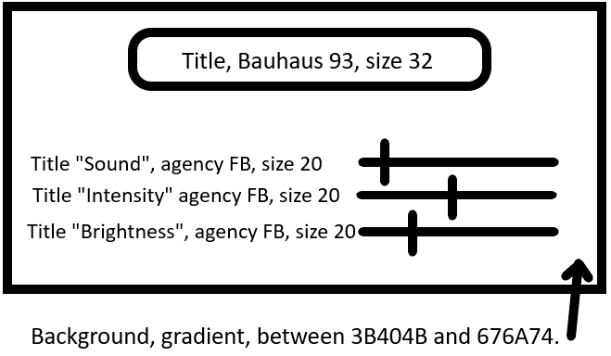

I created these wireframes to give me an idea of how the menu and experience of my project will look and provide reference when I’m creating them, they provide a basic outline of the project and where things will be located and they hold a lot of crucial information such as colours, fonts and font size.

# Assets required

My project would require a great deal of assets as the entire experience is created of 3d models.

### 3d models

I would need an immense amount of 3d models to create the entire experience, I would use blender to create them as it is free, very professional and allows them to be easily exported into programs such as unity.

I would need models for the entire environment and room around the user, and animated models for the user to observe, such as a Bessemer converter, metal presses, conveyor belts, and many more. I would also need models for the users’ arms and a simple base model for the user.

### Audio files

I would need audio files to convey the noise of heavy machinery and also background noise such as voices. For these I would choose to use MP3 files as they are high quality, but also have quite a small file size and are widely used so there will be no compatibility issues.

### Image textures

I would also need image textures to add onto the 3d models such as metal plates, rusted metal and wooden flooring. For these I would use PNGs for similar reasons as to why I would use MP3 files, they are high quality, widely used, and have a reasonably small file size.

### Lighting

I would also need models which emit light, such as flowing molten metal, I would also use blender to create this as it has advanced built in liquid physics, but I would have to add the light emission in another program such as Unity to avoid an errors.

### Assets conclusion

There are a great deal of things to consider when creating assets for a virtual reality project, such as the file size, because the headset has a limited amount of storage space, and needs to be able to render it quickly, which could be an issue if the file sizes where too high. You also have to consider the quality of the experience and low-quality files could decrease this substantially and could even cause user to feel sick.

# Conclusion

This document will be massively helpful when I begin creating my project because it provides so many useful pieces of information such as fonts, font size, colours, assets and basic ideas of where everything will be located, and even how the pages connect, all of this will help me keep to a time frame and make sure I complete the project on time.